6/4/2021

Nadir Hussain

023-18-0025

Computer Networks

Lab 11

**Lab Objectives:**

* Understand the concept of NAT, it’s types and learn configuration.
* Perform one to one mapping
* Perform one to many mapping
* Perform many to many mapping

**NAT: Network address translation**

**What is purpose of NAT?**

We have private IP and public IP, private IPs are reusable and are redundant while public are unique, and We know IPV4 has less addresses as compare to number of devices , so NAT establishes the relation between private and public addresses.

**The mapping of public to private IP can be**

* 1:1: We just use it for proxy : It benefits security
* 1:m This is most usable and benifitial relation applied widely
* m:1 This is not possible
* m:n Private are more as compare to public

**But we perform three mapings which are possible and are useful**

**Task1: One to One configuration**

One public to one private IP mapping

**Network Design:**

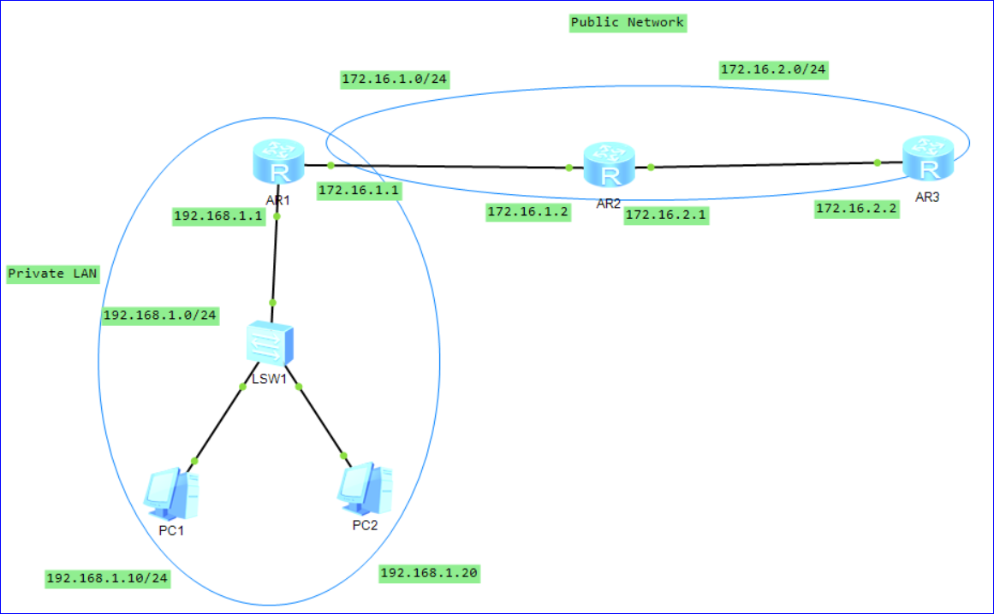

**Configure PCs and interfaces**

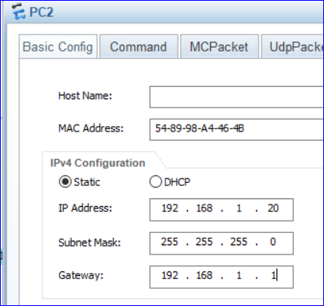

Similarly for PC1

**On Router1**

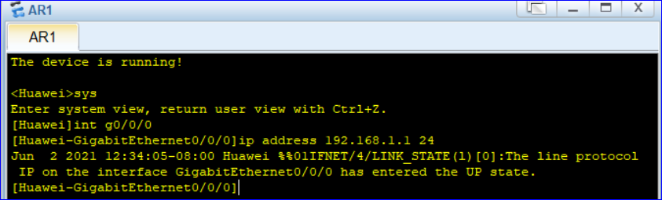

**Similarly int g0/0/1 ip addr 172.16.1.1 24**

PC1 can ping PC2 and our local area is configured

**On Router2**

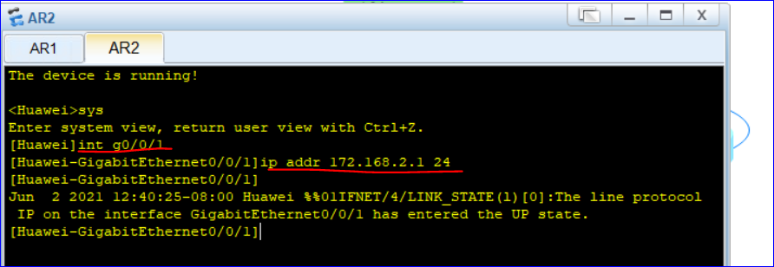

**On Router3**

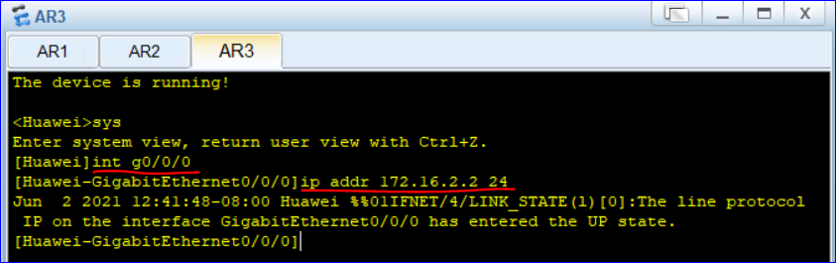

We can’t reach 172.16.1.2, but we should not do routing to reach public network from LAN(private network). So we just configure OSPF routing on public network.

**On Router1**

We will not include LAN in our configuration as ***Router1 is edge or NAT router***

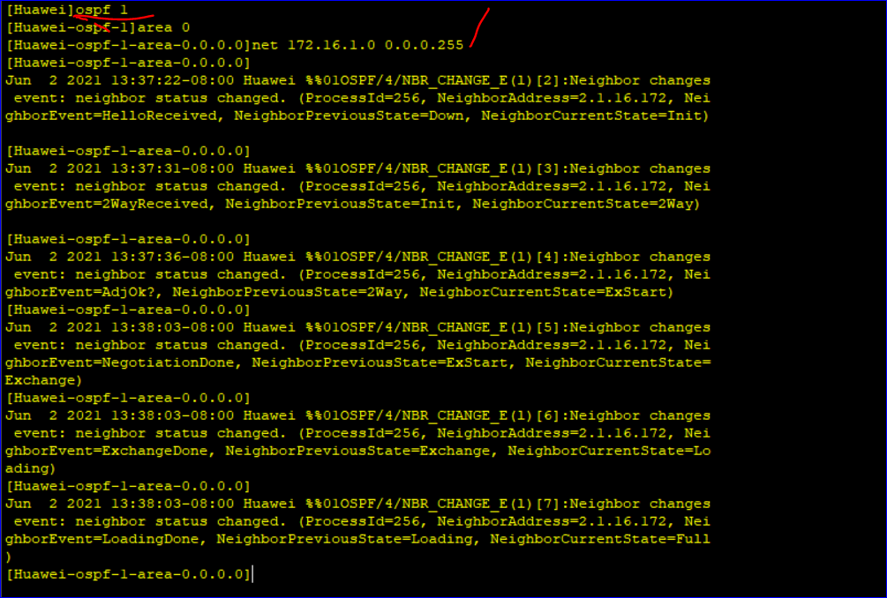

**On Router2**

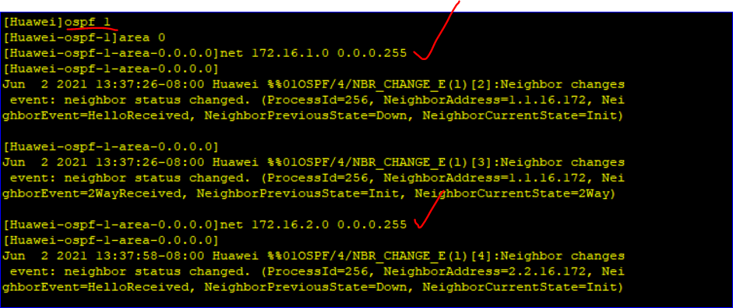

**On Router3**

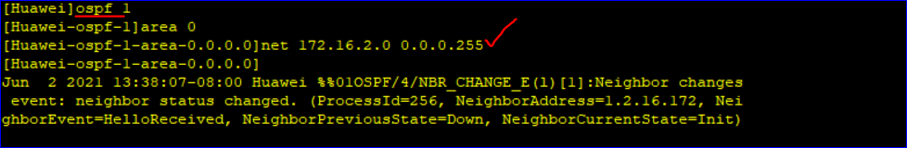

Now we can ping within private and within public, but can’t ping from private to public. But we want to ping from private to public network.

**From interface 172.16.1.1 to 172.16.2.2**

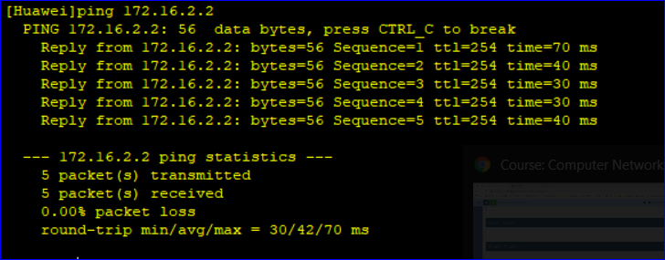

**And from PC1 to interface 172.16.1.2**

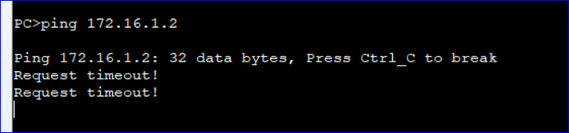

But we want to send traffic to public network from single PC1. What to do? Implement One to one NAT.

**On router1 which is NAT**



Note: We need to define the interface

Now we can ping from PC1 to any interface on public

**From PC1 to 172.16.1.2**

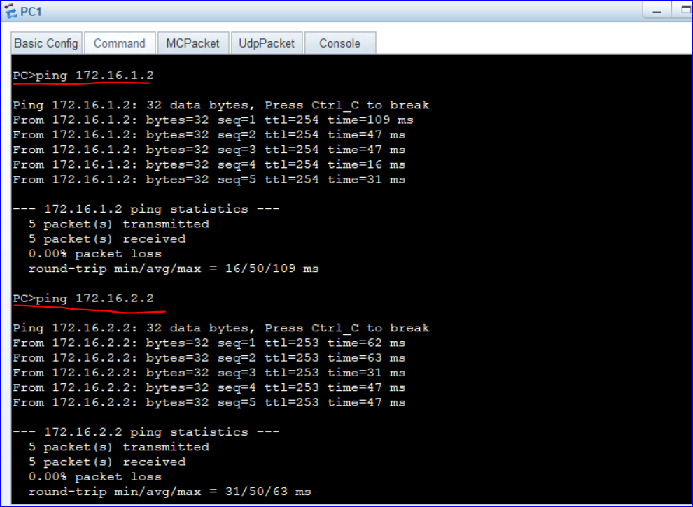

So we have successfully connected to public while being in hidden from outside world.

Now we can **display nat session all** to know all entries in NAT table, remember to ping before seeing information.

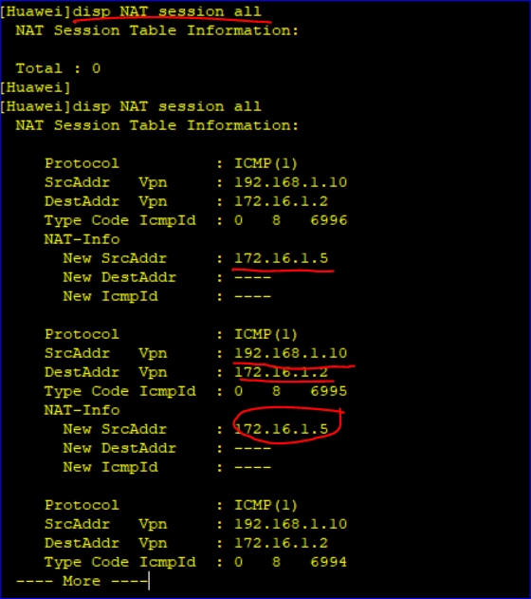

Now we add other IP for PC2, i.e 172.16.1.7 for 192.168.1.20 and we can ping from PC2 to other interfaces of public network



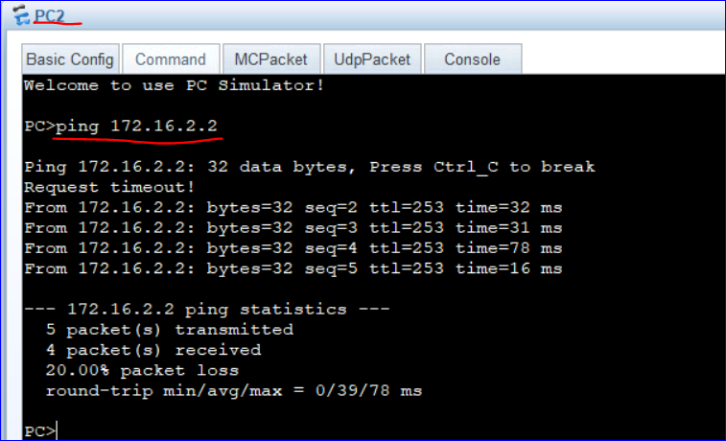

So it was one to one, we needed to create NAT for each PC

**Task2: Many-to-many**

One range for public and other for private

*We can use same topology:*

*Int g0/0/1*

*Undo Nat static global 172.16.1.5 inside 192.168.1.10*

*Undo Nat static global 172.16.1.7 inside 192.168.1.20*

**Then define public and private address groups on router, not on interface**

**NAT address-group 1 172.16.1.5 172.16.1.8 : Contains 4 addresses**

**OR**

**Network design:**

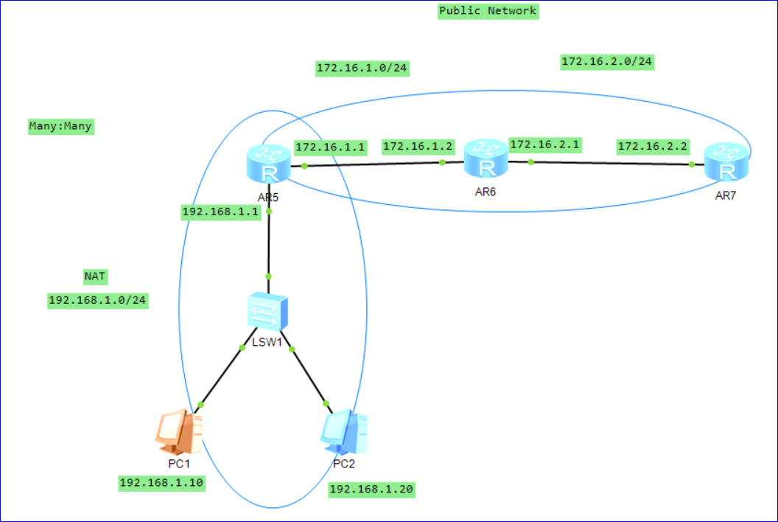

*Configure PCs and interfaces*

*On router1*

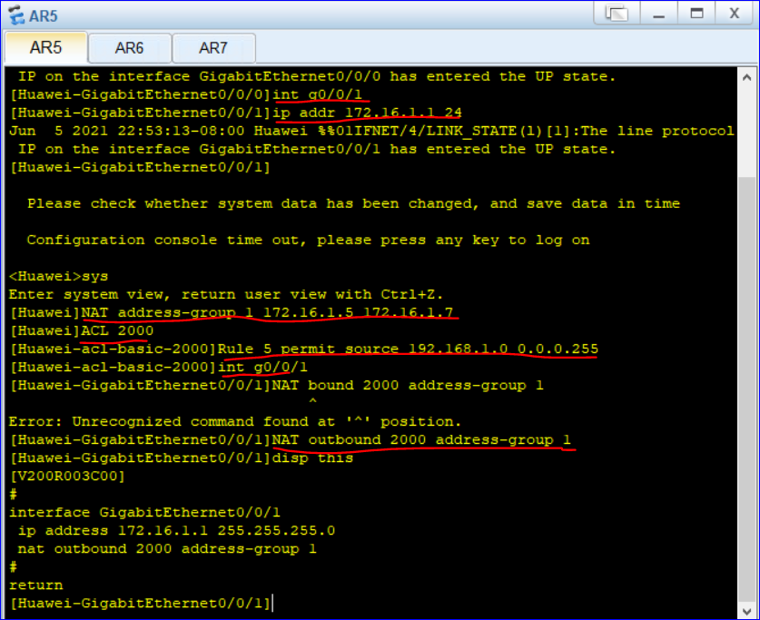

We created public group of IPs from 1 172.16.1.5 172.16.1.7 : It will be distributed on FCFS basis

Then we created basic rule that maps the public addresses to 192.168.1.0 network, as we have two PCs in private network and 3 public addresses so we get 172.16.1.5 and 172.16.1.6.

So the rule permits any IP address from 192.168.1.0 to public group of IPs

Now we can ping from NAT to public: From PC1 to 172.16.

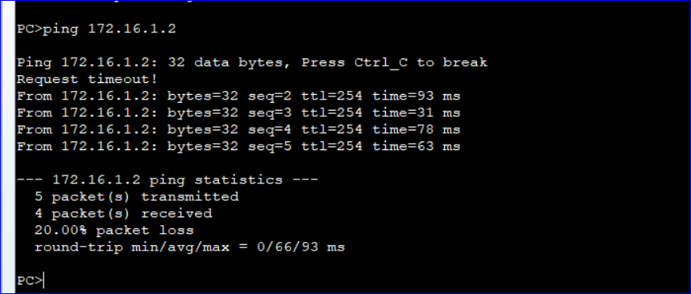

From PC2 to 172.16.2.2: We can not ping because We have IPs of public group from network 172.16.1.0

But we can ping from PC2 to

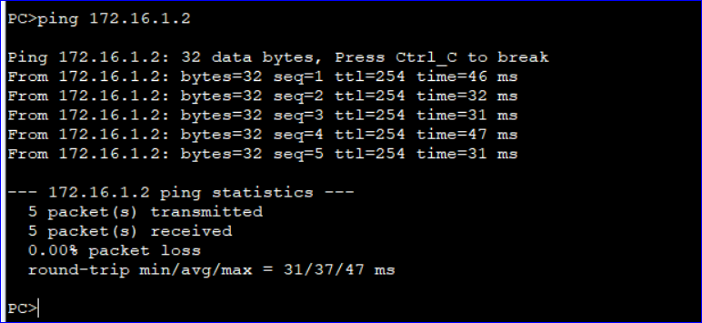

Now let’s display the NAT table by pinging from PC1 and PC2 to public network

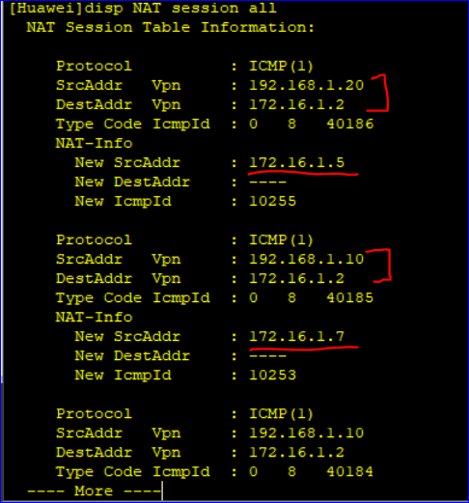

Similarly we can connect to 172.16.2.0 network if we define rule and address-group

**Task3: Implement One to many:**

It is widely used, one public many private. This is scheme is called easy IP. We want to use the interface address as public address. Map all private PCs to public interface of router.

Undo any NAT on public interface of router1

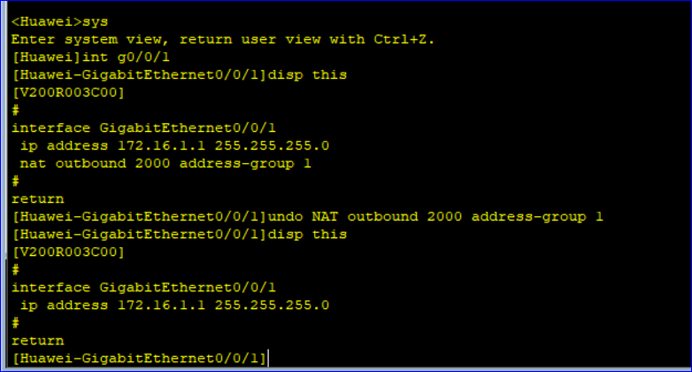

Now configure One to many NAT on interface g0/01 of router1

Now create private list: ACL 2000 and allow them to map on any public addresses.

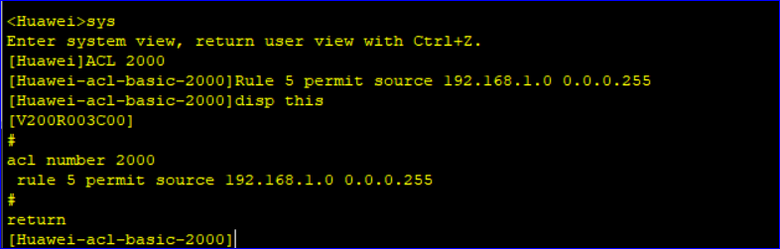

Now map them to public addresses, be on public interface of router1 i.e g0/0/1



Now we have mapped all IPs of NAT i.e 192.168.1.10 and 192.168.1.20 to public IP provided by public interface of router.

Now we can ping from PC1 to public network.

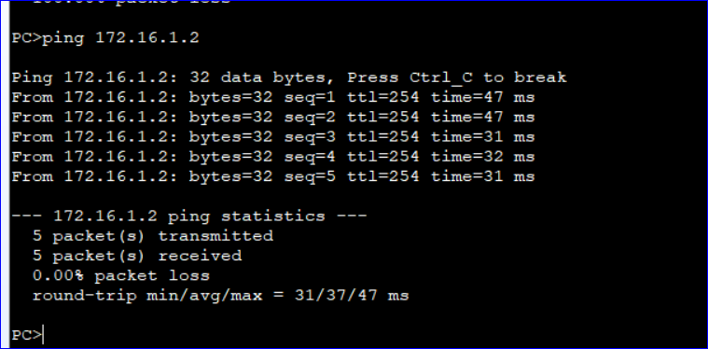

And from PC2 to 1.2

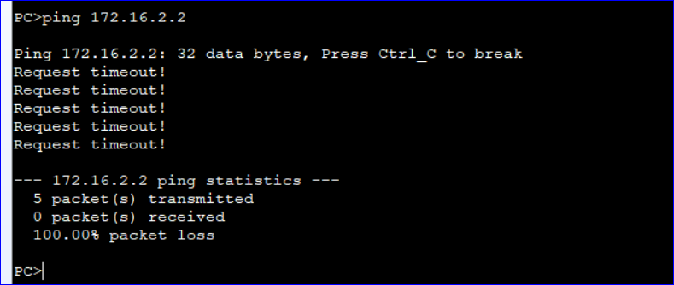

In NAT session table

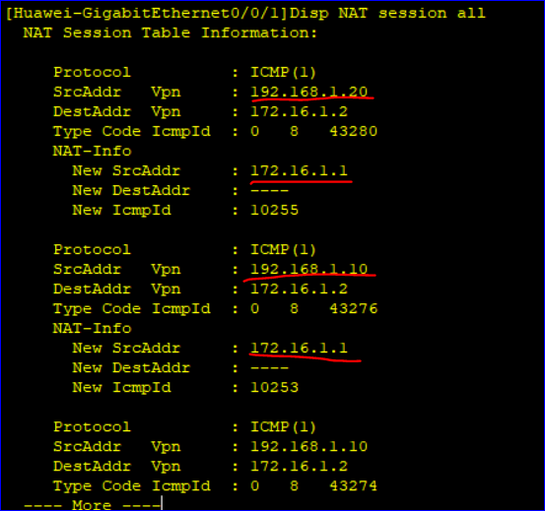

So all PCs in NAT will use 172.16.1.1 as their public address. Which is One to many NAT mapping.

**The End**